BỘ GIAO THÔNG VẬN TẢI
TRƯỜNG ĐẠI HỌC GIAO THÔNG VẬN TẢI TP. HCM


School Year: 2025 - 2026
Course Code : 011968115401

Object-Oriented Programming

TOPIC: CPU Scheduling algorithm:
(FCFS and non-preemptive SJF)

Number | Member | Student Code | Intructor:  Mai Ngọc Châu
1 | Lê Hoàng Minh Khang | 082206004707 | Intructor:  Mai Ngọc Châu
2 | Lương Minh Hiếu | 079206015033
3 | Nguyễn Nhật Toàn | 079206045477
4 | Lê Thế Huy | 083206000728
5 | Phạm Nguyễn Gia Bảo | 079206004263

LỜI NHẬN XÉT CỦA GIẢNG VIÊN
................................................................................................................................
................................................................................................................................
................................................................................................................................
................................................................................................................................
................................................................................................................................
TP. HCM, tháng 1 năm 2026

Mục Lục:

1. Introduce: 3
1.1 Link Project: 3
1.2 Project Overview: 3
1.3 Objectives: 3
1.4 Technologies Used: 3
2. Algorithm Theory: 3
2.1 FCFS (First-Come, First-Served) Algorithm 3
2.2 SJF Non-Preemptive (Shortest Job First) Algorithm 4
3. System Design 5
4. Stress Test Performance Test And Proof 7
4.1 main screen test 7
4.2 performance test (with N= 1000, 10000, 50000) 7
5. Difficulties Encountered 7
6. What We Learned: 8
7. Task Distribution 8
8. Conclusion: 9
9. References: 10

1. Introduce:

1.1 Link Project:
https://github.com/MinhKhang18-04/011968115401-Group07-ProjectCode

1.2 Project Overview:
- This project implements a CPU Scheduling Algorithm Simulator demonstrating two fundamental scheduling algorithms:
• First-Come, First-Served (FCFS)
• Shortest Job First Non-Preemptive (SJF)
The application is developed using C++ programming language
and runs as a console application on Windows/macOS/Linux.

1.3 Objectives:
• Understand CPU scheduling concepts in Operating Systems
• Implement FCFS and SJF scheduling algorithms
• Compare algorithm performance using various metrics
• Visualize scheduling results with Gantt Charts
• Practice modular programming and code organization

1.4 Technologies Used:
• Programming Language: C++
• IDE: Visual Studio Code
• Version Control: Git/GitHub
• Libraries: csv, copy, datetime, time, random (built-in)

2. Algorithm Theory:

2.1 FCFS (First-Come, First-Served) Algorithm
Principle: The process that arrives first is executed first.
Characteristics:
• Non-preemptive scheduling
• Simple and easy to implement
• Fair in terms of arrival order
• May cause "Convoy Effect" (short processes wait for long ones)
Algorithm Steps:
1. Sort processes by arrival time
2. Execute each process in order
3. Calculate completion time, turnaround time, waiting time

Example:
Input:
PID | Arrival Time | Burst Time
P1 | 0 | 5
P2 | 2 | 4
P3 | 3 | 9
P4 | 6 | 2

Gantt Chart:
P1 | P2 | P3 | P4
0 5 9 18 20 Results:
PID | AT | BT | ST | CT | TAT | WT
P1 | 0 | 5 | 0 | 5 | 5 | 0
P2 | 2 | 4 | 5 | 9 | 7 | 3
P3 | 3 | 9 | 9 | 18 | 15 | 6
P4 | 6 | 2 | 18 | 20 | 14 | 12

CT (Completion Time) = ST + BT
TAT (Turnaround Time) = CT − AT
WT (Waiting Time) = TAT – BT

Average Waiting Time: (0+3+6+12)/4 = 5.25
Average Turnaround Time: (5+7+15+14)/4 = 10.25

2.2 SJF Non-Preemptive (Shortest Job First) Algorithm
Principle: Among all arrived processes, execute the one with
shortest burst time first.
Characteristics:
• Non-preemptive scheduling
• Optimal average waiting time (proven mathematically)
• May cause "Starvation" (long processes may never execute)
• Requires knowing burst time in advance
Algorithm Steps:
1. At each time unit, find arrived processes
2. Select process with minimum burst time
3. Execute until completion (non-preemptive)
4. Repeat until all processes complete
Example (same input):
Gantt Chart:
P1 | P4 | P2 | P3
0 5 7 11 20
Execution Order: P1 → P4 → P3 → P2
Results:
PID | AT | BT | ST | CT | TAT | WT
P1 | 0 | 5 | 0 | 5 | 5 | 0
P4 | 3 | 2 | 5 | 7 | 4 | 2
P3 | 1 | 4 | 7 | 11 | 10 | 6
P2 | 2 | 9 | 11 | 20 | 18 | 9
Average Waiting Time: (0+2+6+9)/4 = 4.25
Average Turnaround Time: (5+4+10+18)/4 = 9.25

3. System Design
3.1 Project Structure
011968115401-Group07-ProjectCode/
├── assets/
│ ├── Collaborators.jpg # Project team members
│ ├── FCFS tested photo.jpg # Screenshot of FCFS algorithm testing
│ ├── SJF tested photo.jpg # Screenshot of SJF algorithm testing
│ ├── Performance Test (N=1000,10000,50000).png
│ ├── Performance test photo.png # Performance testing screenshot
│ ├── design.gantt1.jpg # Gantt chart design illustration
│ ├── result.png # Output result visualization
│ ├── result (2).png # Additional output result visualization
│ └── run recording.mp4 # Program execution recording
│
├── docs/
│ └── Operating System.docx # Project report document
│
├── src/
│ ├── fcfs.cpp # FCFS algorithm implementation
│ ├── sjf.cpp # SJF algorithm implementation
│ ├── main.cpp # Main program entry point
│ └── input.csv # Input process data
│
├── README.md # Project overview and instructions
├── cpu.exe # Compiled executable file
├── output_fcfs.csv # FCFS scheduling results
└── output_sjf.csv # SJF scheduling results

3.2 Program Flow
1. Start Program
2. Read processes from CSV file
3. Display input data
4. Run FCFS Algorithm
→ Display results → Draw Gantt Chart → Export CSV
5. Run SJF Algorithm
→ Display results → Draw Gantt Chart → Export CSV
6. Display comparison between algorithms
7. End Program
3.3 Design, Gantt Chart:
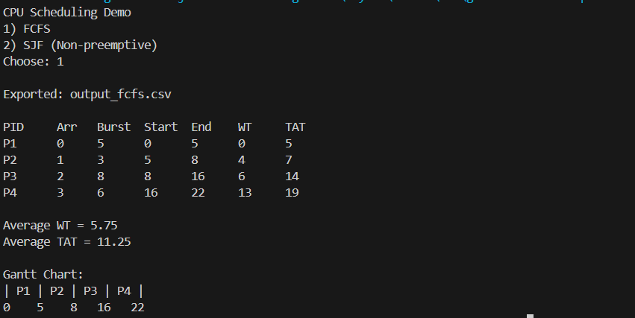

4. Stress Test Performance Test And Proof

4.1 main screen test
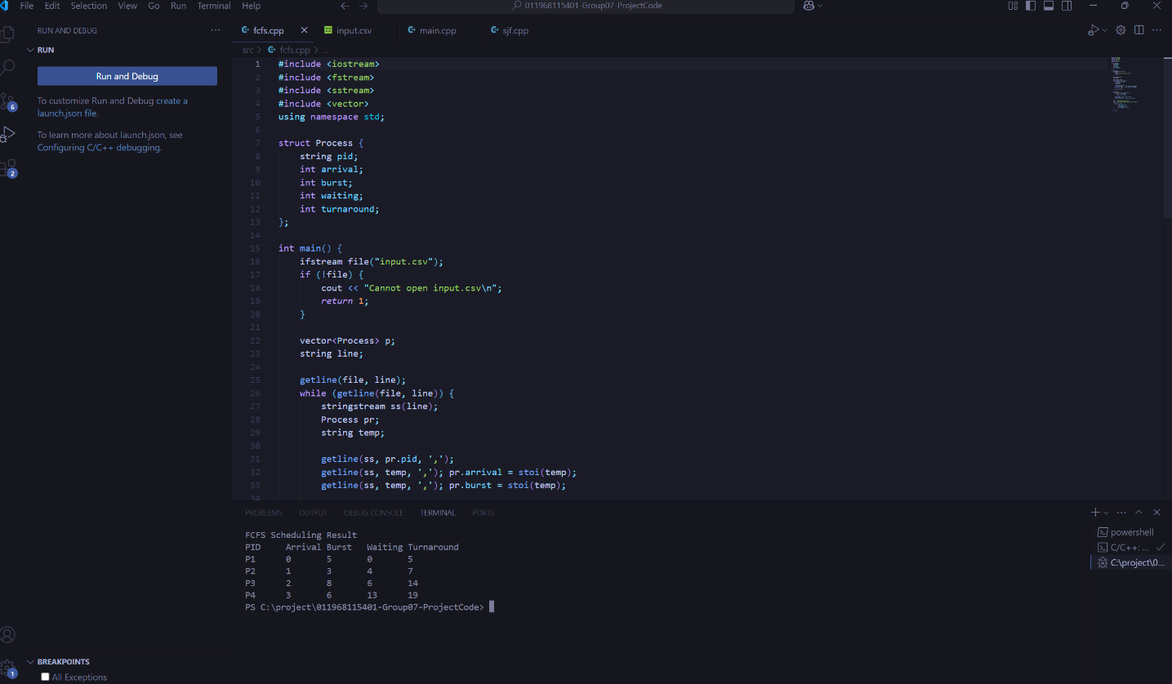

4.2 performance test (with N= 1000, 10000, 50000)
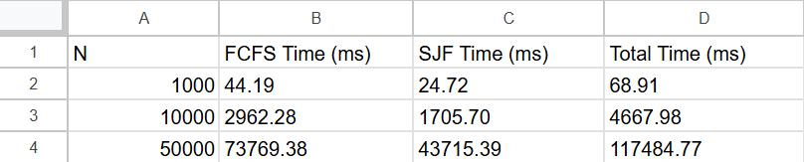

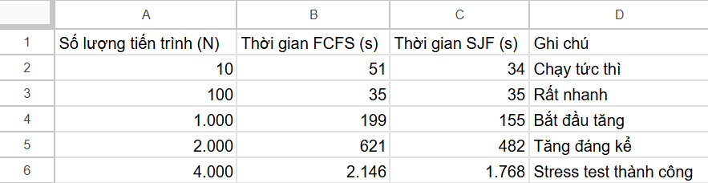

5. Difficulties Encountered
- Some difficulties were encountered while doing this project. First, understanding how CPU scheduling algorithms work in practice was challenging, especially when determining the correct execution order based on arrival time and burst time. Creating accurate Gantt charts required careful calculation and attention to detail. In addition, calculating waiting time and turnaround time for each process was sometimes confusing and time-consuming. Finally, comparing different algorithms and analyzing their performance also required a good understanding of the concepts, which took time to develop.

6. What We Learned:
- Through this project, we gained a deeper understanding of CPU scheduling algorithms, especially FCFS and SJF. We learned how to apply theoretical concepts to real program implementations, including creating Gantt charts and calculating waiting time and turnaround time. Additionally, the project helped us improve our programming skills in C++, file handling with CSV files, and teamwork in managing and organizing project components. Overall, this project strengthened our practical knowledge of operating system scheduling and problem-solving skills.

7. Task Distribution

TEAM MEMBER WORK ASSIGNMENT AND PERFORMANCE EVALUATION SCHEDULE
Numeber | Name | Assgin Work | Assess completion rate | Sign
1 | Lê Hoàng Minh Khang | Leader | 100%
2 | Lương Minh Hiếu | Tester | 100%
3 | Nguyễn Nhật Toàn | Dev | 100%
4 | Lê Thế Huy | Designer | 100%
5 | Phạm Nguyễn Gia Bảo | Writer | 100%

8. Conclusion:
In conclusion, this project successfully implemented and analyzed CPU scheduling algorithms, specifically FCFS and SJF. Through practical implementation and testing, we were able to understand how different scheduling strategies affect system performance in terms of waiting time and turnaround time. The project also enhanced our programming skills, particularly in C++ and file handling, while reinforcing important operating system concepts. Overall, this project provided valuable hands-on experience and a solid foundation for understanding process scheduling in operating systems.

9. References:
[1] A. Silberschatz, P. B. Galvin, and G. Gagne, Operating System Concepts, 10th ed. Wiley, 2018.
[2] A. S. Tanenbaum and H. Bos, Modern Operating Systems, 4th ed. Pearson Education, 2015.
[3] W. Stallings, Operating Systems: Internals and Design Principles, 9th ed. Pearson, 2018.
[4] GeeksforGeeks, “CPU Scheduling in Operating Systems,” Online resource.
[5] TutorialsPoint, “Operating System – CPU Scheduling,” Online resource.

